File No: AF22/04007

4 April 2023

To: | Southern Regional Planning Panel
Cc:
From: | Matt Wilson
Group/Team: | City Development
Subject: | Development Application 10.2022.39717.1 – 421 Elizabeth Mitchell Drive, Thurgoona – Trinity Anglican College Addendum to Albury City Council submission

Albury City Council received written representations on 30 March 2023 regarding condition A8 of the proposed draft notice of determination in relation to development described above. Condition A8 states:
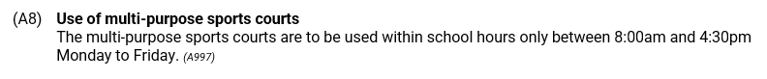

Representations received from Habitat Planning on behalf of the application included the following:

The school would respectfully request that this condition be deleted (preferably) or amended for the following reasons:

- The courts are located more than 50m away from the closest house and is separated by a driveway and linear parkland area.
- The courts have no lights, which will limit the hours they can operate.
- There are currently no restrictions on other facilities or outdoor areas of the school, which will be logistically difficult to implement/enforce.
- The only submission received primarily only raised concerns with the lighting of the court, which could otherwise have allowed use during night time periods
- The courts will be made of a synthetic carpet on a sand bed, which has built in acoustic properties, particularly when compared to the adjacent basketball court contained within a covered outdoor learning area.
- There is no acoustic information to suggest noise generated from the courts will exceed relevant EPA noise criteria.
- The courts will be used for a variety of sports and not just basketball, which would typically generate the most amount of noise (bouncing of balls). Other sports would include soccer, hockey, tennis, netball, volleyball and the like.
- Applying restricted hours will prevent the co-sharing of facilities outside of normal school hours with the community as per the NSW Design Quality Principles for Schools:

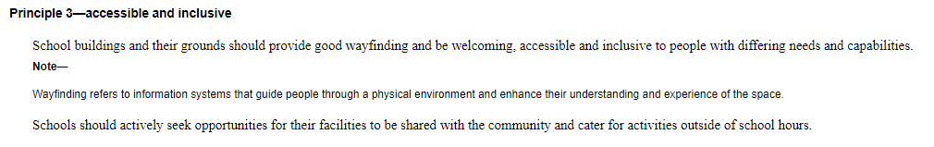

Albury City Council comments:
Condition A8 was conceived in response to the proposed lighting of the multi-sports court. The proposed lighting towers were removed on drawings in response to a further information request seeking additional information regarding the proposed lighting. The drawings are notated – Multi-Sports Court to not have external lighting. However, the statement of environmental effects provided in February 2023 still references lighting in the development description – Open aired multi-sports courts including fencing and lighting.

While there may be some question of consistency between the statement of environmental effects submitted in February and the revised plans, Council is satisfied that the court is not proposed to be externally lit. Further, it is acknowledged that the likely after-hours use of the court will be restricted by the absence of such lighting. Therefore, considering hours of operation are not employed to control other aspects of the development, removal of condition A8 is considered acceptable.

Matt Wilson
Team Leader Development

